**Arpita Sahu**

**Contact**

**Address:**

Bhubaneswar,Odisha

**Phone:**

+918328980852

**E-mail :**

[arpitasahu5595@gmail.com](mailto:arpitasahu5595@gmail.com)

**LinkedIn:** https

**Skills**

* Java
* SQL
* HTML
* Css
* Github
* Jenkins
* Linux

# Summary

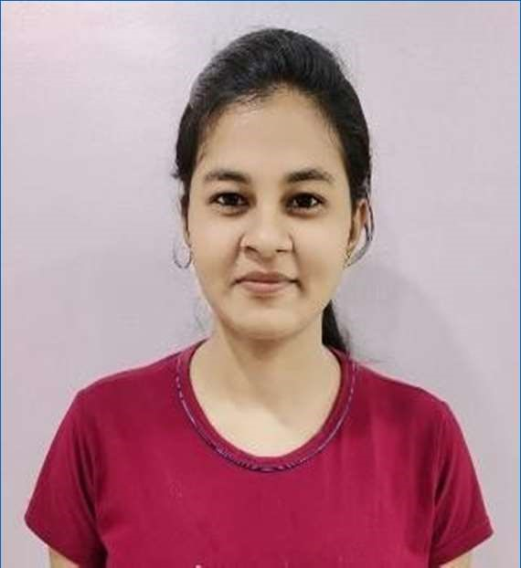

* Experienced programmer with **5.5 years** of relevant experience in the field of **SDLC** with the main concentration on **data analysis**, **data migration** & **visualization techniques** using data driven tools & techniques by working on various **machine learning algorithms** and help delivering project requirements through excellent problem-solving capabilities

# Objective

* Looking for a **Senior Data Analyst Role** eager to contribute to a company success through advanced understanding of statistical, algebraic and other analytical techniques to break down information, gather relevant points and solve advance business problem through various **data analysis** tools & techniques.

# Work History

2021-07-21

Current

2021-01

2021-07

## Business Consultant - II

*EXL Service*

* Currently Working as a Lead Data Analyst for **Prudential** as a client where data have been mapped from **SQL WORKBECH to AWS RED SHIFT cluster** along with data quality work using **AWS Glue Crawler** and **lambda functions** for automating the business use case.
* Worked as a Consultant for **Western Union** as a client in helping in their business requirements delivery through data acquisition, analysis and driving insights through machine learning model developments , KPI reporting and driving business to a higher level.
* Developed a complete **POWER BI Dashboard** for the **AUSTRALIA**

region for the client **PROFITABILITY** analysis

## Developer & Instructor

*iNeuron.ai*

* + Worked as a developer as a Data Analyst so as to create meaningful insights from data & thereby creating content & developing applications for the company…

2021-01

**Software**

* Eclipse
* Jupyter
* R Studio
* Microsoft Azure Studio
* Tableau
* Power BI
* MS Office
* Jenkins
* Git
* Jira
* Stash
* Service Now

**Cloud Technologies**

* SNOWFLAKE
* AWS

2021-02

2020-08

2020-09

2020-03

2021-01

2015-05

2017-03

## Fellowship

*Alphaa AI - Online*

* + Started learning creating a story by designing dashboards to showcase data visualization in Excel

## Data Scientist Intern

*Rapid Pricer B.V,Remote Work*

* + Worked for a month and designed a fully functional dashboard in Excel & Tableau.

## Online Post Graduate Data Certification Course

*Purdue University in partnership with Simplilearn & IBM*

* + Underwent a professional upgradation course in order to equip myself with the relevant skills required in IT industry by learning Data Science and mastered the concepts of statistics, data science and its applications, Python and R programming, machine learning, Tableau, and natural language processing.
  + Designed [**E-Commerce-Sales-Dashboard-in-Excel**](https://github.com/anandjha90/E-Commerce-Sales-Dashboard-in-Excel)
  + Performed different [**Data-Visualization**](https://github.com/anandjha90/Data-Visualization)techniques with the help of R Programming.
  + Exploratory Data Analysis was done on

[**Analysing-Ad-Budgets-for-different-media-channels**](https://github.com/anandjha90/Analysing-Ad-Budgets-for-different-media-channels)

* + Built a model using linear regression with **97%**

accuracy and got an insights on

[**Building-a-model- to-predict-Diabetes**](https://github.com/anandjha90/Building-a-model-to-predict-Diabetes)

* + This program also introduced me to integrated Blended Learning by providing the skills learned by solving a real- world, industry-aligned data science problem as part of the Capstone project

## Associate Software Engineer

*Manhattan Associates India Development Centre, Bangalore, Karnataka*

* + Took care of complete backend development using Spring & Hibernate framework in order to expedite supply chain operations.
  + Designed a UI using HTML & Javascript.
    - Interacting with the consultant to understand the project and finalize its scope.
    - Development of modules based on functional specification and design documents.
    - Co-ordination with the testing team for fixing bugs.
    - Tech document and delivery notes preparation.
    - Resolved supply chain problems and provided exceptional client support

2014-11

2015-04

## Assistant System Engineer Trainee

*Infosys, Mysore, Karnataka*

* + Hands on Training on **SAP ABAP** Domain coupled with basic programming knowledge on **C,C++,Java,SQL and Software Engineering**
  + Completed one real life project and implemented successfully on SAP ABAP tools.

# Education

2022-04

2024-04

2020-03

2020-12

### M.Tech Data Science & Engineering

*Currently undergoing my Master’s program from BITS PILANI under Work Integrated Learning Programme (****WILP****)*

### Post Graduate Program: Data Science

*SimpliLearn In Partnership With Purdue University in collaboration with IBM - Online*

2010-08

**Software Development Methodologies**

* Waterfall
* Agile
* Scrum

**Languages**

* English
* Hindi

**Interests**

* Marathon Runner
* Exploring Places
* Photography
* Passionate Cook
* Playing Badminton
* Learning New Technology
* Teaching & Mentoring

**Certifications**

* Post Graduate Course In Data Science.
* IBM Watson For Chatbots
* PGP – Tableau Desktop 10
* PGP – Machine Learning
* PGP – Data Science with Python
* PGP – Natural Language Processing

2014-07

### Bachelor of Engineering: Electronics & Communications

*PES Institute Of Technology - Bangalore*

* Graduated with **8.15** CGPA
* Qualified **GATE** Exam with **AIR 8845**
* Member of Pixel Photography Club & Robotics

### First Class with distinction in all the semester.

* Awarded Top grade **S** in final semester for the project work.
* Thesis: **Bridge Monitoring System** and represented paper publication under **International Journal of Innovative Studies in Sciences and Engineering Technology (IJISSET)**

2007-08

2009-05

### All India Senior School Certification Examination: PCM & CS

*Jawahar Vidya Mandir Shyamali - Ranchi,Jharkhand*

* Passed with **86.7 %**

2006-07

2007-05

### All India Secondary School Examination: Science & IT

*DAV Kapildev Public School - Ranchi,Jharkhand*

* Passed with **94.30%**
* Secured rank in Top **5%** of Class
* Microsoft Azure Machine Learning Foundations
* Business Analytics with Excel
* PGP – Data Science with R
* Statistics Essential for Data Science

**Additional Information**

* Certified Career Counsellor & Mentor
* Member of World Vision India (NGO) and sponsored a girl child

# Accomplishments

### RESEARCH ON SMALL SCALE NANO SATELLITE PI-SAT UNDER

**CORI LAB (PESIT)** where I was actively involved in project requirements in order to successfully develop **NANO Satellite**, which was later sent to **ISRO** for launch.

* + Completed training programme in **Solar Field Technology**, **PLC and Wireless Technology**, at **Indian Institute of Technology, Mumbai** and made an efficient solar charger with **74%** efficiency.

### First Class with distinction in all semester while pursuing my engineering degree.

* + Published paper under **International Journal of Innovative Studies in Sciences and Engineering Technology (IJISSET)**
  + Scored **299** in **GRE** and **90** in **TOEFL** and attained **above** world average under **writing** & **speaking** section in **English Proficiency** Test